1. What is the initial output voltage (before any voltage has leaked off) of a 1-cm2 piezoelectric sensor composed of a 150-µm thick PVDF film when it is exposed to the applied force caused by a 20 g weight, with 23 pC/N, and ϵr,PVDF = 12? [hint(s): *f = ma, 1 N = 1 kg m/s2*, ϵo = 8.85E-12 F/m]

ϵo = 8.85E-12 F/m ϵr,PVDF = 12  *kPVDF* = 23 pC/N x=150m

*Force: 1 N = 1kg*m/s2* *f = ma = 0.02 kg9.807 m/s2 = 0.1961 N A = 0.0001 m2*

1. A thermistor temperature sensor placed in a bridge circuit has been put in a biomedical application to measure the temperature of a neonate’s body temperature, which provides feedback to a thermal blanket used to keep the neonates body temperature close to 37 oC. The following bridge circuit shows the thermistor represented as R1. If R3 and R4 are fixed at 1kΩ, and the calibrated resistance at T0 = 0 oC, R2 = 500Ω, with a supply voltage of 10V, and α = 0.00395/oC, what is the measured bridge voltage *Vo* for a temperature of 37 oC? What is the difference in voltage measured if the neonates body temperature drops from 37 oC to 34 oC?

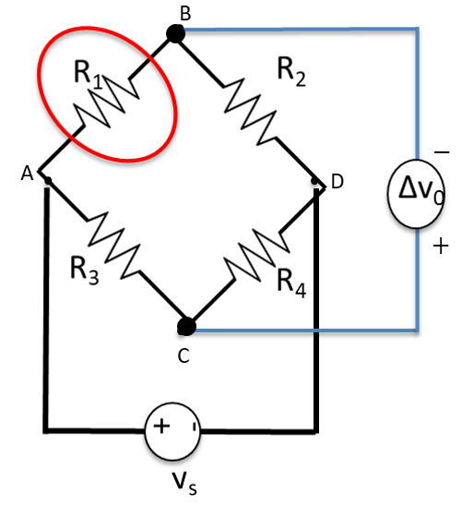

**Answer:**

For a balanced bridge

Thus, since , we must have when the bridge is balanced. I.e., the thermistor has a resistance of 500 at the balance point of 0 C.

For the thermistor,

At 37 C

At 34 C

Thus, if the temperature drops to 34 C, the voltage decreases by 26 mV.

**Aside:** Since the thermistor provides feedback for the thermal blanket, the sign of the difference in voltage is extremely important for controlling the thermal blanket because a decrease in output voltage from the bridge corresponds to a decrease in the neonate’s temperature measured by the thermistor. If the bridge circuit output was +25.9 mV instead of mV, the measured temperature would be 40 oC.

**Problem 3:** For the LVDT shown in Figure A, sketch the voltages c-e, e-d and c-d as a function of time when the core is (1) in the top position, (2) in the middle position, and (3) in the bottom position shown. (You will generate three graphs of voltage vs. time, one for each position, each graph having three curves.) Assume that the frequency of the oscillator in the figure is 1 kHz. (See Lecture 6, Slides 10 and 11).

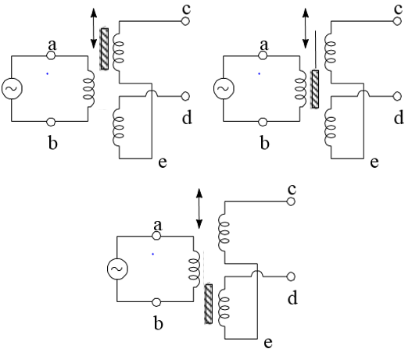

**Figure A:** Inductive displacement sensor based on a differential transformer.

**Answer:**

When the core is displaced upward, c-e will be largest, e-d will be smaller and 180 degrees out of phase with c-e, and c-d will be slightly smaller than c-e, with the same phase.

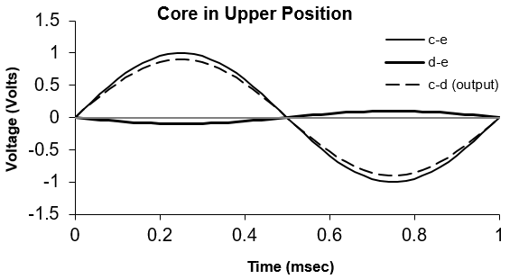

When the core is in the middle position, c-e and e-d will be smaller, and opposite one another, and the output will be zero.

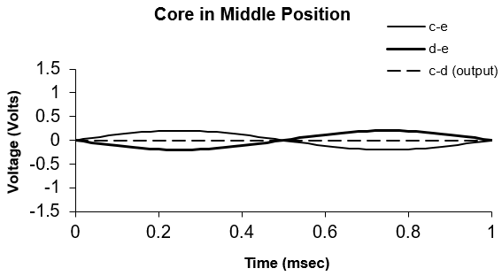

When the core is displaced downward, c-e will be smallest, e-d will be largest (and opposite of c-e), and the output will be slightly smaller than c-d, with the same phase as c-d.

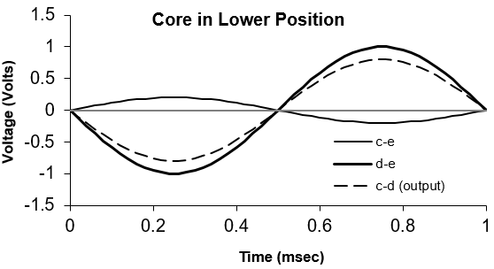

**Problem 4:** You have a sensor that measures velocity. You can convert it to displacement sensor if you integrate the output over time.

1. Assuming that the output impedance of the sensor is low but unpredictable (on the order of 50 , but possibly as low as 20 and as high as 100 ), and that the calibration factor for the sensor is 1 Volt/(mm/s), sketch an operational amplifier circuit that provides a voltage calibration factor of 10 Volt/mm.

**Answer:** Clearly, we need an integrator. We need the input impedance of the circuit to be much greater than the source’s output impedance. A value of 10 k would probably be fine (an attenuation caused by the output impedance of less than 1%. But we may as well go as high as 100 k. The integrating operational amplifier response is . The dimensions of are therefore (1 Volt/(mm/s))(sec)/. Thus, we need to have to get the gain of 10. The 100 k resistor then needs to be paired with a 1 F capacitor. The result is.

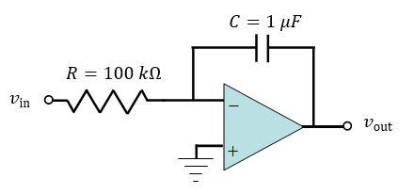

1. If the velocity sensor had an offset (finite output for zero velocity input), why would that be problematic to the circuit you designed in Part a.

**Answer:** The offset would be continually integrated and cause to steadily change with no input. Ultimately, it would integrate to the limit of the power supplies.

1. If you now want a transducer that responds to acceleration, how could you add an operational amplifier circuit to the original sensor to obtain an accelerometer with a calibration factor of 0.05 V/(cm2/s)?

**Answer:** Now you need a differentiator. The conversion is . The calibration factor requires that . An example circuit is

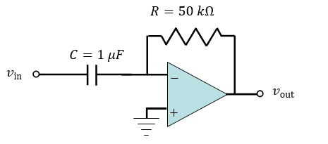

Velocity

Acceleration

1. If the sensor’s output impedance is large and unpredictable (possibly as low as 100 k and as high as 1 M) and you want the calibration factor to be positive, how could you modify the circuit in Part a.

**Answer:** To get a larger input impedance, place a voltage follower between the sensor and the input of the integrator. Then, to get a positive calibration factor, add an inverter to the output of the integrator.

**Problem 5 (Electrical Safety):** A subject with wet hands grabs a 10 Volt RMS power line with one hand and grounds himself with the other over two seconds. Deduce

(5 pts) The amount of current that passes through the subject.

We need to determine the rms current for this action. Wet skin has a resistance of about 1 k, so the current is .

(5 p[ts) The most likely consequences of the current to the subject.

From Figure 14.1 of Webster (Slide 12 of Lecture 2 on Electrical Safety), this current is at the low end of the let-go current. Some small risk exists that the subject will not be able to let go of the line. Most likely, the subject will be able to feel the current, with a warming sensation.

**Problem 6: (Lecture on Sensors and Bridges, “Inductance (Capacitance) Bridge” slide)** A variable inductor is used as its main sensing element for a given biomedical measurement. The inductance of this element changes in proportion to the signal of interest. The inductor is placed in a Wheatstone bridge configuration, with three unchanging inductors as the other three arms of the bridge. Sketch the circuitry required to translate the inductance to a DC signal.

**Answer:**

We can borrow from the referenced slide. We need only add the rectifier.

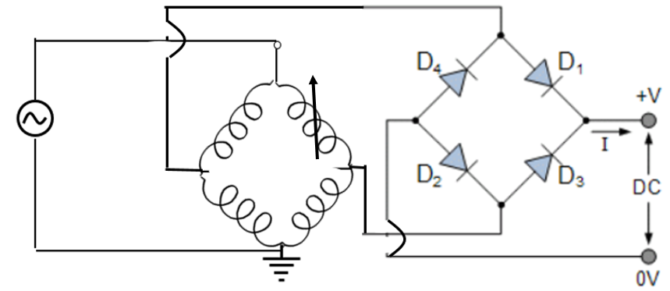

**Problem 7:** Sketch a setup that you could use to measure the rotation rate of a DC motor, where your primary sensor is each of the following (i.e. sketch a total of 5 setups). Assume that the motor drives a disk and that it is the rotation rate of the disk that you will directly measure. (I am interested in how the rotation rate of the disk alters some characteristic of the sensor, how that change in the characteristic is translated to a voltage, and how a voltage is translated to the rotation rate. E.g., for 4, how would the rotation of the disk change the dial position, how can you convert the dial position to a voltage, and how can you use the voltage to deduce rotation rate? You do not need to provide details of the voltage to frequency conversion circuit, if such a circuit is needed. Also, refrain from placing any of the electronics on the disk itself so that wires do not become twisted as the disk rotates.)

1. A photoresistor (perhaps in combination with a laser)
2. A strain gauge
3. An inductor (perhaps in a bridge circuit)
4. A dial potentiometer
5. A thermocouple

**Answer:**

1. You may come up with other ideas. Here are some simple solutions that occurred to me.

Attach a disk to the rotating shaft of the motor. Drill a hole in the disk, and align the laser such that it shines through the hole once per rotation. Place the photoresistor on the other side in a simple bridge. Use a frequency-to-voltage converter to count the number of times per second that the voltage from the bridge jumps when the laser strikes the photoresistor.

**Solution:**

Attach a disk to the rotating shaft of the motor. Drill a hole in the disk, and align the laser such that it shines through the hole once per rotation. Place the photoresistor on the other side in a simple bridge. Use a frequency-to-voltage converter to count the number of times per second that the voltage from the bridge jumps when the laser strikes the photoresistor.

Motor

Volts

Frequency to Voltage Converter

Rotation Rate

Laser

Each time the laser light passes through the hole in the disk, it reduces the photoresistor resistance, which decreases (i.e., causes a downward pulse on ).

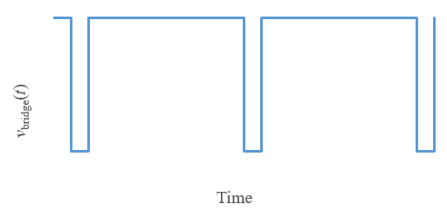

The frequency to voltage converter then provides a voltage output that is proportional to the frequency of the downward pulses (hence proportional to the rotation ate of the disk).

1. Attach the shaft of the motor to a friction bearing (where , with torque, the friction coefficient, and the rotation rate), and attach the bearing to the strain gauge. A higher rotation rate then causes a larger torque and therefore a larger force on the strain gauge.
2. Use the same disk that was introduced with the photoresistor, but instead of drilling a hole, attach a piece of metal to it. Place the inductor, in a bridge circuit, near the disk so that its inductance changes when it is near the metal piece.
3. Attach the shaft of the motor to the dial. As the motor rotates, the resistance will change as a periodic function in time. Then use a bridge network and a threshold detector to count zero crossings per second.
4. Use the same technique as with the photoresistor. The laser shines on the thermocouple and heats it for a short time for each rotation. (Of course, the signal is likely to be much lower than the photoresistor signal).

**Problem 8:** (Thought exercise) Tachometers generally count the number of events in a given amount of time (such as the number of times light is reflected from a reflective surface that rotates with the rotating target). This strategy will not distinguish between clockwise and counter-clockwise rotation. How could you modify this strategy or devise a new strategy to provide a signal that is positive for a clockwise rotation and negative for a counterclockwise rotation?

Answer:

A switch can be added that turns on during clockwise rotation and off during counter-clockwise rotation. The switch can be used to direct the Tachometer output directly as a positive output for clockwise rotation, or through an inverting amplifier to get negative output for counter-clockwise rotation.

A gyroscope can be used to detect clockwise or counterclockwise rotation.

**Graduate Content**

**Problem 9:** Use LTSpice to model the two full-wave rectifier circuits (one LTSpice model per circuit) shown in Lecture 5. The first is based on simple diodes. The second is based on MOSFET transistors. Since you will need to feed the and signals to a differential amplifier, use the LT1168 chip. Run the simulations with a 1 kHz, 5 volt amplitude sine wave. Comment on the quality of the two rectifiers. Which provides a more accurate rectified signal?

**Answer**

**Diode Rectifier**

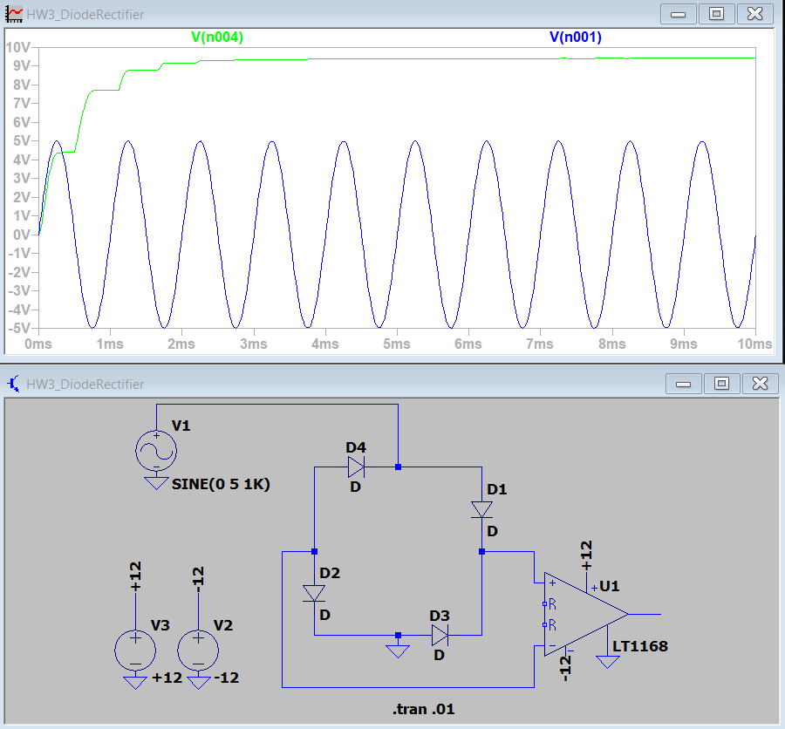

Figure : Diode rectifier.

**MOSFET Rectifier**

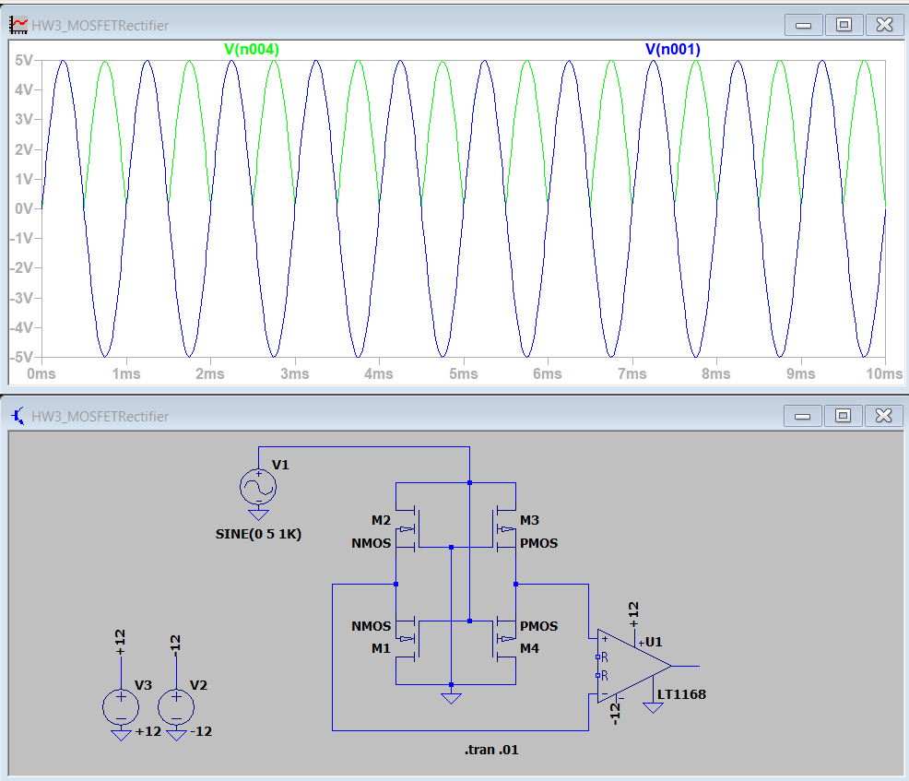

Figure : MOSFET rectifier